**PRINCIPAL COMPONENT ANALYSIS**

**Large datasets are increasingly common and are often difficult to interpret. Principal component analysis (PCA) is a technique for reducing the dimensionality of such datasets, increasing interpretability but at the same time minimizing information loss. It does so by creating new uncorrelated variables that successively maximize variance.**

**Principal component analysis (PCA) is the process of computing the principal components and using them to perform a change of basis on the data, sometimes using only the first few principal components and ignoring the rest.**

* **PCA is an unsupervised pre-processing task that is carried out before applying any ML algorithm. PCA is based on “orthogonal linear transformation” which is a mathematical technique to project the attributes of a data set onto a new coordinate system. The attribute which describes the most variance is called the first principal component and is placed at the first coordinate.**
* **Similarly, the attribute which stands second in describing variance is called a second principal component and so on. In short, the complete dataset can be expressed in terms of principal components. Usually, more than 90% of the variance is explained by two/three principal components.**
* **Principal component analysis, or PCA, thus converts data from high dimensional space to low dimensional space by selecting the most important attributes that capture maximum information about the dataset.**

**Explained variance is a statistical measure of how much variation in a dataset can be attributed to each of the principal components (eigenvectors) generated by the principal component analysis (PCA) method. In very basic terms, it refers to the amount of variability in a data set that can be attributed to each individual principal component. In other words, it tells us how much of the total variance is “explained” by each component. This is important because it allows us to rank the components in order of importance, and to focus on the most important ones when interpreting the results of our analysis.**

**Tabulation of sets and their corresponding training and testing errors and percentage of variance explained:**

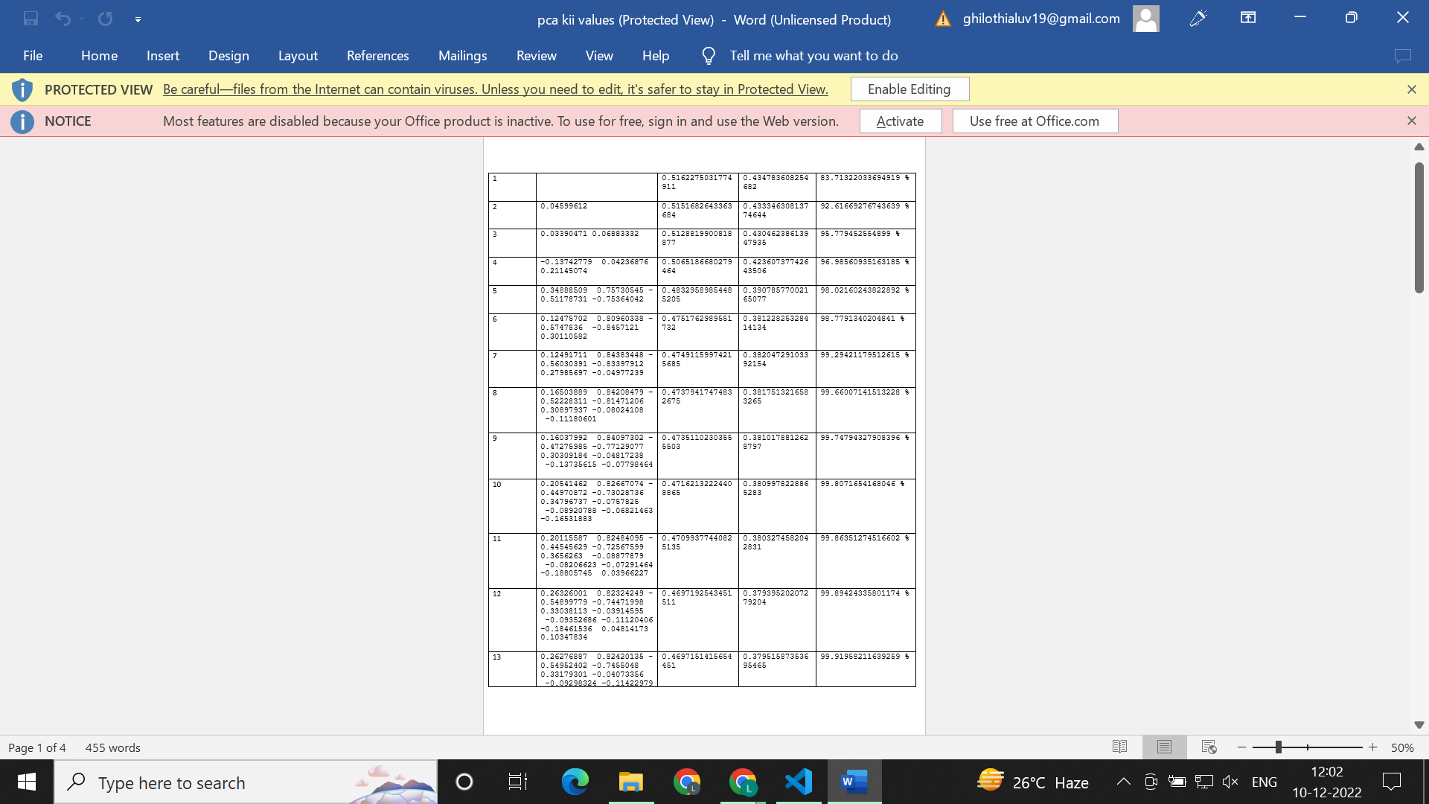

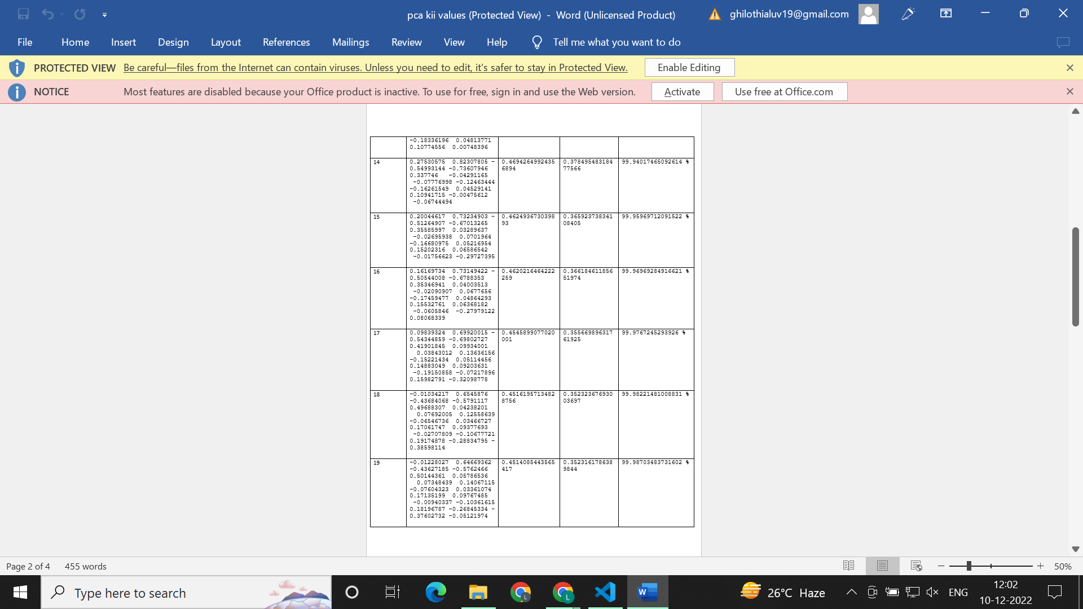

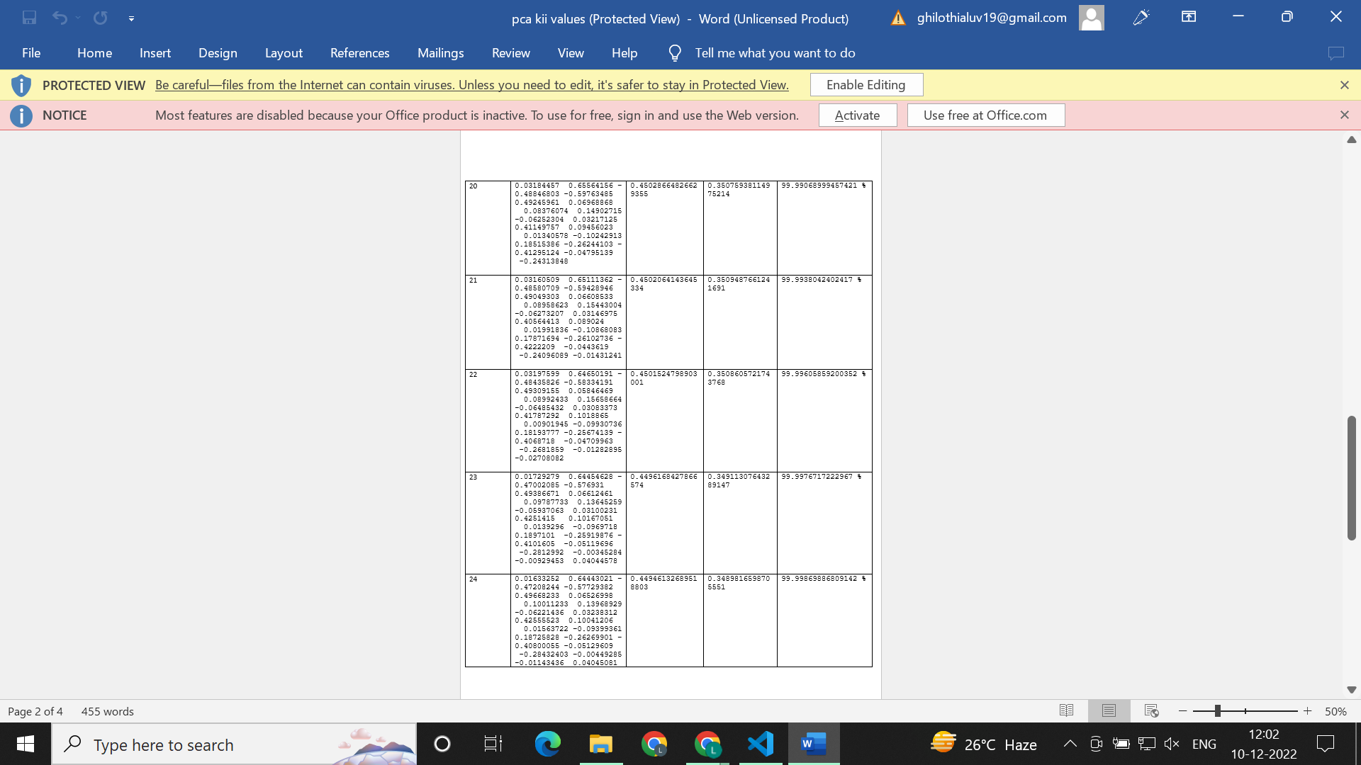

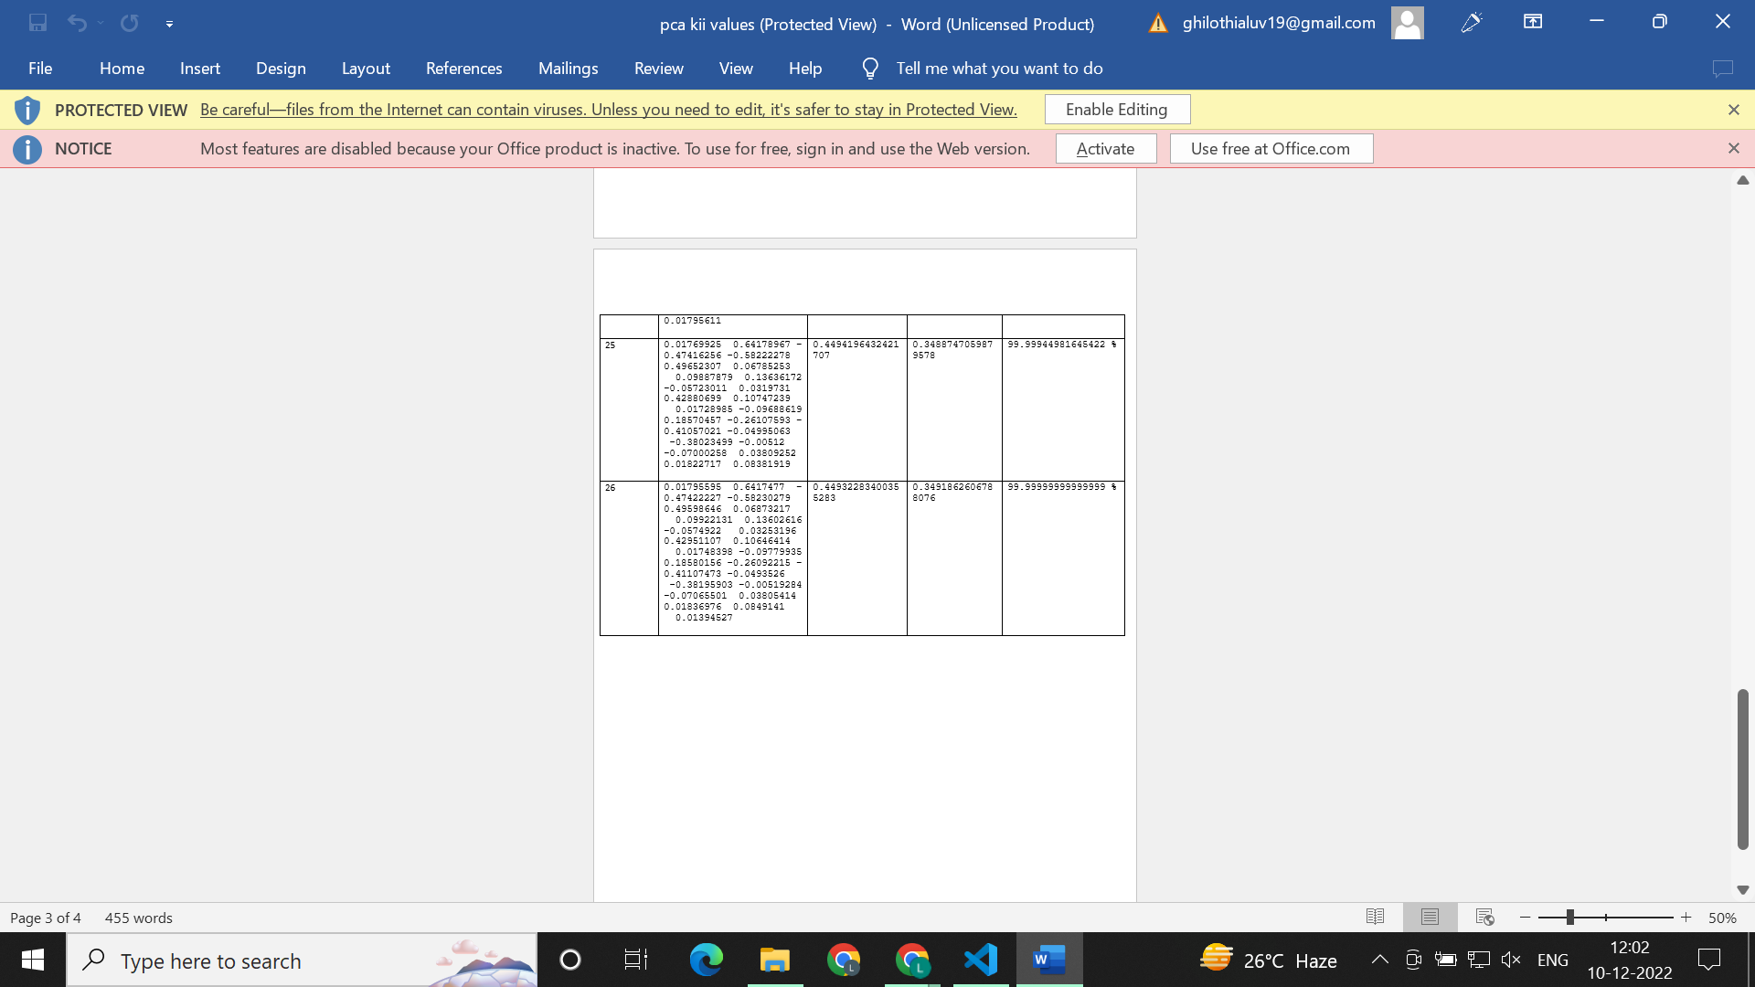

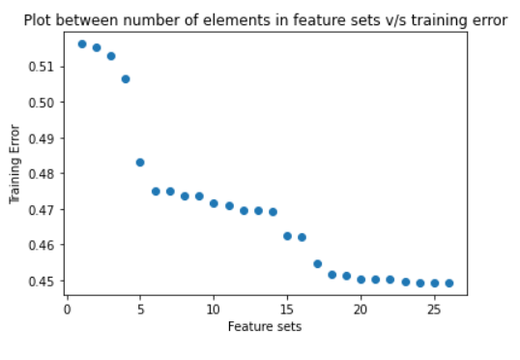

**In the plot between number of elements in feature sets vs training error, the training error decreases with increasing number of feature sets.**

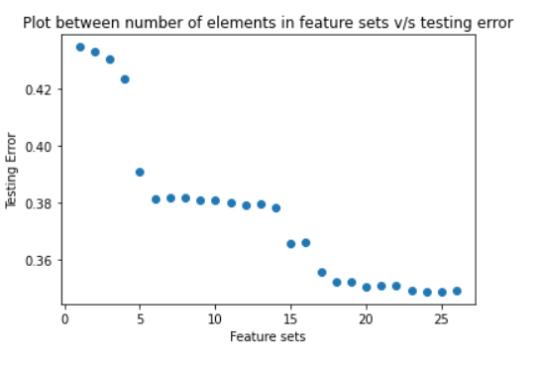

**In the plot between number of elements in feature sets vs testing error, the testing error decreases with increasing number of feature sets.**

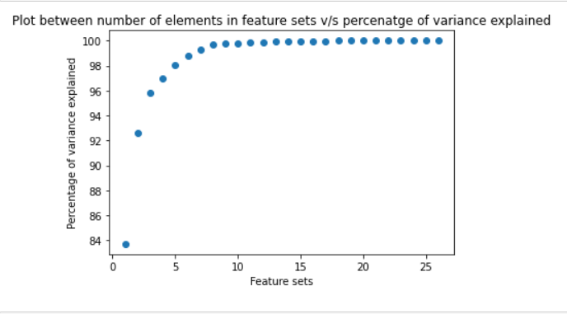

**In the plot between number of elements in feature sets vs percentage of variance explained, the percentage of variance explained increases with increasing number of feature sets.**